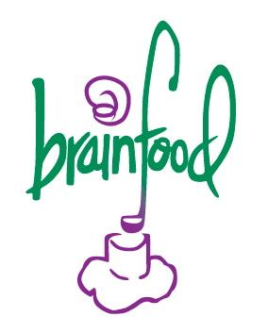
Brainfood Kitchen All Stars
2015 - 2016 Application
October through May, 4 PM-6:30 PM

NAME: ________________________________________________________ NICKNAME: ___________________
(LAST NAME) (FIRST NAME)

GENDER: __________ DATE OF BIRTH: ___________________

STREET ADDRESS: _____________________________________ CITY: _______________ STATE: _____ ZIP: _____________

HOME PHONE: ( ) _ ___ CELL PHONE: ( ) _ ____ BEST TIME TO CALL: ____________

EMAIL ADDRESS: ____________________________ HOW OFTEN DO YOU CHECK YOUR EMAIL? DAILY WEEKLY MONTHLY

GUARDIAN NAME: __________________________________________ DOES YOUR GUARDIAN SPEAK ENGLISH? YES NO

GUARDIAN PHONE (HOME): (WORK): (CELL): _____________________

SCHOOL: ___________________________ GRADE: ___ HOMEROOM: ____________________ STUDENT ID: ___________
How did you hear about Brainfood? ______________________________________________________________________________________________________
Why do you want to participate in Brainfood Kitchen All Stars? What do you hope to get out of this experience? ____________________________________________________________________________________________________________________________________________________________________________________________________________
Is there anything specific you would like to learn about food, nutrition, and cooking?
____________________________________________________________________________________________________________________________________________________________________________________________________________
What other after school activities (sports, summer school, work, travel, etc.) do you participate in during the school year?
__________________________________________________________________________________________________________________________________________________________________________________________________________________________________________________________________________________________________________________

How would you describe yourself? ____________________________________________________________________________________________________________________________________________________________________________________________________________

Are you able to attend Brainfood Kitchen All Stars for the entire school year? (October – May) Yes No
If no, please explain:

We have 4 classes being offered.
Please  any class schedules that you can attend.
Please circle your preferred class.

Chinatown (H St and 8th St NW)
___ Monday & Wednesday 4:00 – 6:30pm
Tuesday & Thursday 4:00 – 6:30pm

Columbia Heights (16th St & Newton St NW)
__ Monday & Wednesday 4:00 – 6:30pm
Tuesday & Thursday 4:00 – 6:30pm

